RESERVATION FORM- NIRWANA GARDENS
NIRWANA GARDENS WIND CHALLENGE 2018
02 ~ 04 FEBRUARY 2018 (FRIDAY TO SUNDAY)

For reservation, please fill-up the booking form and forward to
Email: yana@nirwanagardens.com.sg or winnie.chua@nirwanagardens.com.sg
Tel: 65 6213 5838 or 65 6213 5792 Fax: 65 6291 1343
www.nirwanagardens.com

□ |  | New Reservation |  |  |  |  | □ | Amendment
Name of Guest : |  |  | __________________________ Contact Tel : __________________________
Email Address : |  |  | __________________________ Contact Fax : __________________________
ROOM BOOKING
Check In Date : __________________________ Check Out Date : _______________________

3D2N NIRWANA RESORT HOTEL (NRH) OR NIRWANA BEACH CLUB (NBC) STAY PACKAGE

(In 02Feb Out 04Feb 2018)
 | 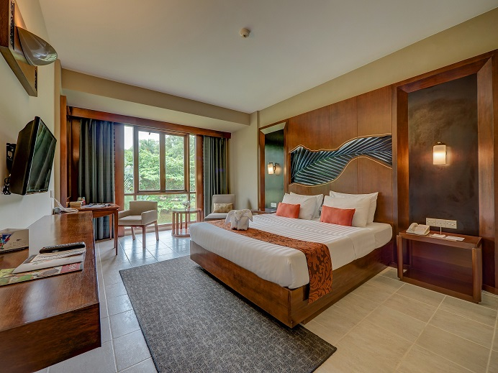 |  |  |  | NRH Nirwana Room (Garden View)  S$605nett per person – Adult Single occupancy □  S$445nett per person – Adult Twin Sharing (02pax to a room) □
 | 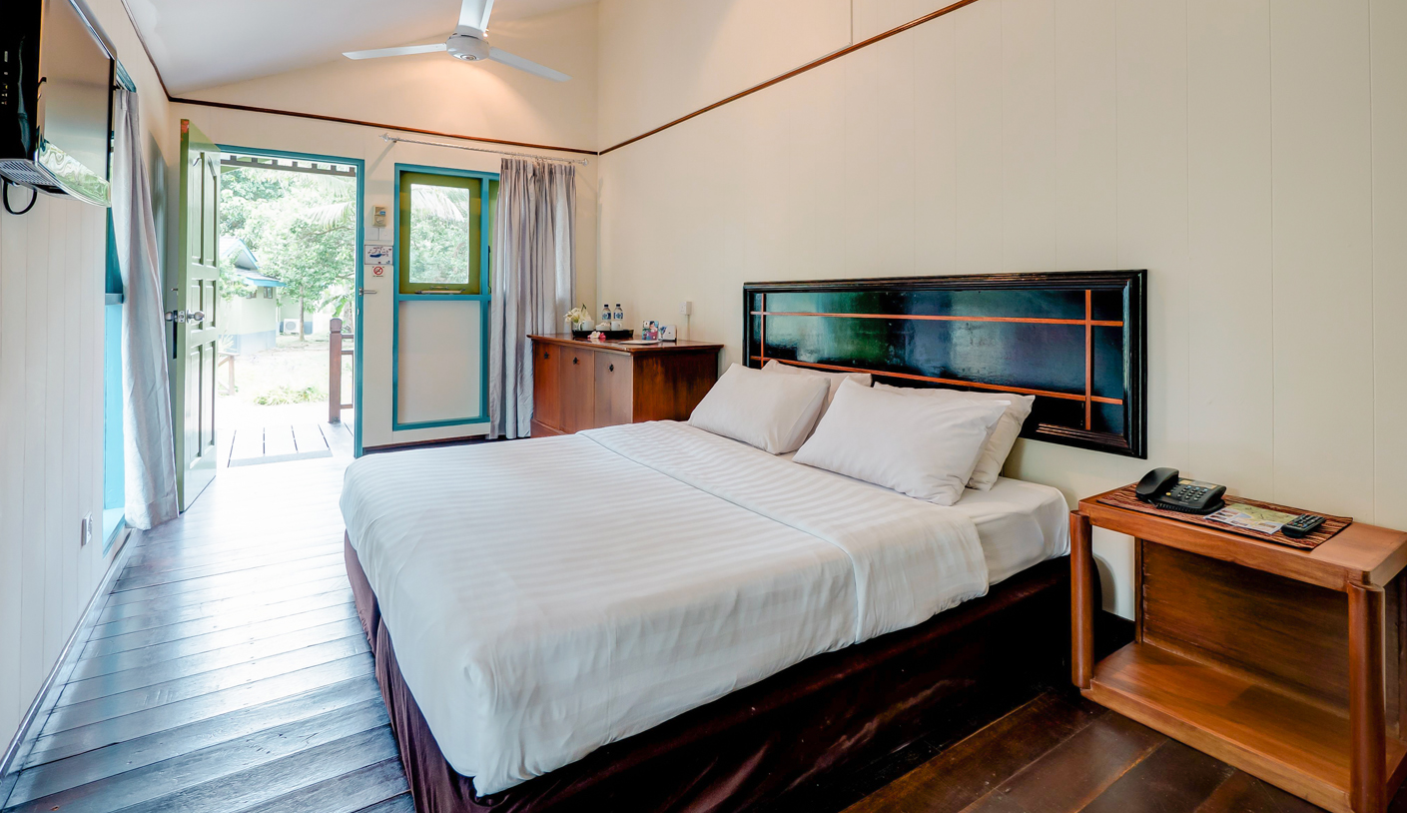 |  |  |  | Nirwana Beach Club  S$485nett per person – Adult Single occupancy □  S$385nett per person – Adult Twin Sharing (02pax to a room) □

ABOVE PACKAGE INCLUDE
- Two night accommodation in – Nirwana Resort Hotel, Nirwana Room (garden view) or Nirwana Beach Club – as per prices indicated
- Return Singapore/Bintan-BBT/Singapore economy class ferry ticket including taxes^
- Two way land transfers from Bintan Ferry Terminal to Hotel to Bintan Ferry Terminal
- Welcome drink upon arrival
- Meal Plans : 2 Buffet Breakfast + 3 set/buffet lunch + 1 set/buffet dinner + 1 BBQ buffet dinner at designated venue
- PLUS! Complimentary basic Wifi Internet usage
- Complimentary coffee & tea making facilities in the hotelroom
- Complimentary bottled mineral water in the hotelroom
- Complimentary usage of Nirwana Gym at Resort Centre
- Package rates are inclusive of 10% service charge and prevailing government tax, presently at 11%.

BEVERAGE
*Beverages during meals are not inclusive in mentioned package and chargeable based on consumption basis
*15% Discount off Beverage at F&B outlets except for Room Service, Neydles House and Hot Pot

*Wrist band will be provided for identification purposes

TERMS & CONDITIONS
- Above package valid only for travel during the above mentioned days
- No refund for partial utilization of package
- Confirmation subject to availability. Full payment required upon confirmation of booking
- Weekdays: Sundays-Thursday, Weekends: Friday, Saturdays

Optional Pre & Post Stay inclusive Breakfast for up to 02pax
NRH Nirwana Room (Garden View) | S$140nett per room per night □
Nirwana Beach Club | S$80nett per room per night □
- Pre-event dates: 31 January & 01 February 2018; Post-event dates: 04 & 05 February 2018
- Pre & Post of stay is subject to room availability. Post stay rates are strictly for consecutive stay through 04 February 2018

Note:
Check-in Time : 1500 hours
Check-out Time : 1200 hours
The above timing is based on local Indonesian Time. Kindly note that early check in & late checkout is subject to availability only. Please reconfirm with front office staff for any late checkout request.

~ Indonesian time is 1 hour behind Singapore time (e.g. Singapore time @ 0900hr / Indonesian time @ 0800hr)
~ Room bedding will be subjected to availability

CHILD POLICY (FERRY & MEALS NOT INCLUDED)
For child with Extra-bed, it is chargeable at S$60nett per bed per night with breakfast
For child without Extra-bed, it is chargeable at S$30nett per night with breakfast
For 2 Adults with 2 children in a room, one Extra-bed is compulsory per room
Maximum no. of 02 children to share a room with two adults
Child denotes 3-11 years old

Maximum base on per room | Surcharge for child
2Adults + 1Child OR 1Adult + 2 Children (no extra-bed is required) | S$ 30nett
2Adults + 1Child OR 1 Adult + 2 Children (with extra-bed) | S$ 60 nett
2Adults + 2Children (compulsory 1 extra-bed) | S$ 60 nett + S$ 30 nett

GUEST DETAILS
Name 1 as in Passport: |  | Passport Number:  Date of Expiry:
Date of Birth |  | Nationality
 |  | Gender | Male / Female

Name 1 as in Passport: |  | Passport Number:  Date of Expiry:
Date of Birth |  | Nationality
 |  | Gender | Male / Female

Ferry Reservation (please tick to select time according to date)
Singapore – Bintan (Singapore Time)
31 January, 01 & 02 February 2018 (Wednesday, Thursday & Friday)
□ 0910 hrs □ 1110 hrs □ 1400 hrs □ 1700 hrs □ 2000 hrs

Bintan – Singapore (Bintan Time – 1 hr behind Singapore)
04 February 2018 (Sunday)
□ 0835 hrs □ 1135 hrs □ 1435 hrs □ 1535 hrs □ 1635hrs □ 1735hrs □ 2015hrs
OR
05 & 06 February 2018 (Mondy & Tuesday)
□ 0835 hrs □ 1135 hrs □ 1435 hrs □ 1735hrs □ 2015hrs

IMPORTANT NOTES:
- It is the passengers’ responsibility to obtain a visa and have a passport that is valid for a minimum of six months at the time of travel.
- Reservation will be confirmed upon receipt of full payment only.
- No cancellations after confirmation of room & ferry, otherwise full package charge will be imposed. Package is non-refundable.

PAYMENT

Debit Authorization
I hereby authorize Nirwana Gardens to use the credit card details given below for payment for my booking. I understood that full cancellation charge applicable as per terms & conditions stated above and no refund will be accorded, if applicable.
Credit Card : | VISA / MASTER / AMEX (please circle accordingly)
Credit Card No. : |  | Security No/ CCV :
Credit Card Holder’s Name : |  | Expiry Date :
3D2N Stay Package :  Pre night(s) stay :  Post night(s) stay :  Total : | NRH Nirwana Room (Garden View)  S$605nett per person – Adult Single occupancy □  S$445nett per person – Adult Twin Sharing (02pax to a room) □  Nirwana Beach Club  S$485nett per person – Adult Single occupancy □  S$385nett per person – Adult Twin Sharing (02pax to a room) □  S$______ x ______ nights = S$_________  S$______ x ______ nights = S$_________  S$_______
Grand Total : | S$ |  | Signature :

For Official Use | Keyed By : | Date : | Package Confirmation No. :
 |  |  | Ferry Confirmation No. :

REVISED VISA RULING
The Government of Indonesia had imposed “Visa on arrival” for the following country: Libya
Visa fees are USD 15 – Valid for 7 days & USD $35 for Maximum 30 days payable on arrival.
Currently there are 169 countries that are exempted from visa – visit Bintan Resort Ferries web site at http://www.brf.com.sg for more information.

